2022-23 Oregon IDA Request for Proposals
Contents
Introduction 2
Part 1: Equity and Accessibility questions
(all questions required for all FOs) 4
Part 2: Proposals for Expansion Match Funds 5
Template for proposal type A.
Growth and/or changes in existing programming 5
Template for proposal type B.
Regional expansion and/or new partnerships 6
Part 3: Program and Administration
Budget Narrative 8

2022 IDA RFP Snapshot
This is an unusual RFP. This visual is to help you navigate. Successful submissions require that you review the complete RFP (this document) and support materials (on the Portal) prior to beginning your proposal. As you work through this word version of the RFP all sections that need to answered and submitted through the portal will be highlighted blue to further aid navigation.
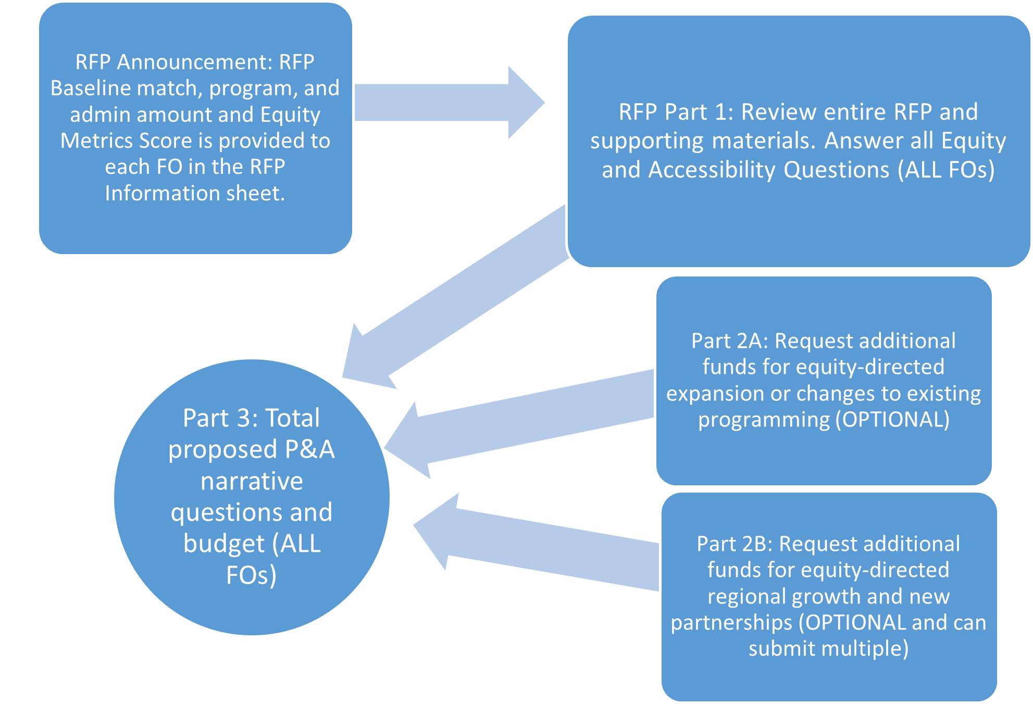
Introduction
The Oregon IDA Initiative was established as a wealth building program addressing poverty. IDA statute Section 4(2) states:
“Family economic well-being does not come solely from income, spending or consumption, but instead requires savings, investment and the accumulation of assets.”
Twenty years later, the differential between rich and poor on a wealth basis has only deepened, and qualitative and quantitative data have demonstrated that this divide has deep systemic and structural roots despite a longstanding story told about the power of individual effort and merit. That divide plays out differentially for Oregon’s BIPOC residents, who experience an additional wealth gap in relation to white Oregonians. From the grassroots of our neighborhoods to the highest levels of state government, there is a growing recognition that a focused attention on race equity is a key element on a path toward prosperity for all. Reaching universal prosperity—health, wellbeing, and a capacity to thrive and provide—continues to require building household and community wealth, to build financial stability and security in an economic system that that is structured to maintain inequality.
In 2021, the IDA Initiative shifted the language in our statute from a very specific goal of promoting job training, higher education, home ownership and small business development to an actionable vision that promotes and facilitates overall financial stability and resilience of lower-income households. A human- and community equity-centered design shift has encouraged the Initiative to re-orient toward the expertise and lived experience of savers to identify the needs they will meet with IDA match funds. In 2017 the Initiative had already broadened the range of available asset goals, to better meet savers where they are at.
Two simple understandings guide the strategic direction of our programming and allocation of funding: People need wealth to build wealth, and there persists a significant racial wealth gap in Oregon.
To address the need for wealth to build wealth, we are leveraging the expansion of asset goals to support all low-income Oregonians—Black, brown, and white—to receive IDA resources in the ways that best support them where they are at today. For some, today is the most urgent issue, and IDAs can be a part of building a bridge from survival to stability and the opportunity to start saving. For others, IDA match can provide a base toward active financial wealth building to support the individual and their community tomorrow and generationally.
This need for a baseline of wealth to build wealth is additionally complicated for BIPOC Oregonians because of systemic racism. The racial wealth gap is the result of demonstrable historic and ongoing state policy, taxation, redlining, and carceral policies, as well as policy and practice in private businesses, including financial institutions from large banks to check cashing businesses. Oregon specifically has been shaped by a history of explicit racial exclusion laws. According to the Federal Reserve Board, in 2019 the median net worth of white households was $188,000 while for Black households it was $24,000 and for Latinx households $36,000.
Therefore, in addition to universal efforts to increase access to wealth building, the IDA Initiative centers targeted efforts to ensure that IDAs reach BIPOC communities at a rate higher than their representation in the low-income population, with the goal to provide an impactful level of funds and tools to increase access to wealth building in BIPOC communities in Oregon.
NP has identified five service regions statewide, with population data disaggregated by race and ethnicity, for low- and moderate-income (LMI) residents. This population data, when compared with similarly disaggregated data on IDAs, provides a benchmark to better identify where the IDA resource is and is not reaching rural and BIPOC communities. Our goal is to support the Initiative and providers to develop targeted strategies to increase enrollments and completions in IDAs for BIPOC Oregonians. As an Initiative, we continue a collective project of increasing our understanding, skills, and tools for staff in organizations across Oregon to provide more culturally responsive support for savers to accomplish their financial goals.
Technical notes:
- This document contains the questions you will need to answer to submit the RFP. All sections that need to be answered to submit your RFP are highlighted in blue to help you navigate. Part 2 is optional, so the blue sections are required only if submitting a proposal.
- NP will not accept submissions in Word format. If you draft responses in a Word document, please copy/paste into the submission form linked in the RFP Portal.
- You will also need to submit the Excel budget form through the submission form as an attachment.

Part 1: Equity and Accessibility questions (all questions required for all FOs)
Notes:
Questions are provided here for reference, with word counts. Completed answers will need to be submitted through the submission form linked in the RFP Portal.
These questions will inform final funding decisions, work plan development direction, and Initiative investments.
NP is aware that funding proposals are a significant burden, and we want to explicitly welcome you to use responses from other funding proposals that align with our questions.
- Who does your organization serve? How does that align with or differ from your existing IDA participant base? (150 words)
- What are your IDA program’s future goals for serving BIPOC individuals living in your service area? (200 words)
- If your program serves rural Oregon, how are you addressing challenges of accessibility and differential access to resources for individuals and communities outside the immediate radius of your location? (200 words)
- Are there other specific economically vulnerable communities that your organization does or plans to reach with IDAs, including immigrants and refugees, people experiencing disabilities, veterans, people who have been impacted by domestic violence, youth in or previously in foster care, and/or youth or adults impacted by incarceration? Please be specific about what capacity you have to be responsive to the unique needs of different economically vulnerable communities. (300 words)
- How did your organization support staff with racial equity, culturally specific training or learning opportunities in the 2021-22 program year? How did these opportunities ensure that staff were supported to meet clients where they are at, in a culturally responsive and/or culturally specific manner? (300 words)
- What commitments has your organization or IDA Program made toward advancing or centering racial equity in your overall mission and specifically in your IDA program? (300 words)

Part 2: Proposals for Expansion Match Funds
Note: Submitting proposals for this funding is optional, and answers will not affect the core funding level.
In addition to baseline funding to support the strong existing IDA programming statewide, at minimum $1.3M of our available funding will be awarded to support:
- Expansion and/or changes in existing programming that will have clear impacts in advancing Initiative race equity goals
- Regional growth and new partnerships that will further the reach of IDAs geographically and among under-represented BIPOC communities
Your final RFP submission may have multiple funding requests. If you have a proposal that includes multiple funding requests for different goals or geographic regions served, you may complete multiple “Additional Funds Proposals” for each request. Please provide as much distinction between proposals as possible, as not all proposals may receive funding.
Materials and Data to Support Proposals:
- Initiative and FO level equity benchmark outcomes. Each FO has received their organization-specific results in advance of this funding cycle. NP will be relying on this data in considering proposals. Please reach out if you need support understanding your report or the Initiative level outcomes.
- Initiative Level Regional Gaps & Opportunities package PDF. Available on the RFP Portal. Highlights areas where IDAs are underrepresented by region.
- FO-specific RFP Information Sheet. Emailed with RFP Announcement. Includes your program’s core funding amounts and equity score, accompanied by an explanation of how the score was calculated.
Additional Funds Proposal
Technical Note: You can submit more than one proposal, and you can submit both types of proposals. There is a single template for each type below that you can duplicate as needed. In the submission form, you will be prompted to add another proposal in the submission form once your first entry is complete.
Template for proposal type A.
- Growth and/or changes in existing programming that will have clear impacts in advancing Initiative race equity goals.
Funds Request (Review Part 3 before completing this section)
- How much additional IDA Match are you requesting for this additional proposal? ___________
- How much additional Program funds are you requesting for this additional proposal? ______________
- How much additional Admin funds are you requesting for this additional proposal? ______________
Proposal Questions
Note: You can specify more than one high level proposal. The form will prompt you to add another in the submission form once your first entry is complete.
- High level Proposal Description (50 words or less):
- Up to five Subgoals or activities required to reach goal (20 words or less each)
- Accountability: What measurement criteria or outcomes will allow us to understand if the goal was successful? (50 words or less)
What is your Equity Metrics Score? (Refer to your FO-Specific RFP Information sheet included in the announcement email from NP): __________
- If your program’s Equity Metrics Score is below 3:
What measures are planned or underway that will improve outcomes for BIPOC savers in your region/s? How will your program’s capacity to enact and support these measures be impacted by the additional work included in the proposal you are submitting for expansion funds. (300 words)
Template for proposal type B.
- Regional expansion and/or new partnerships that will further the reach of IDAs geographically and among under-represented BIPOC communities
Funds Request (Review Part 3 before completing this section)
- How much additional IDA Match are you requesting for this additional proposal? ___________
- How much additional Program funds are you requesting for this additional proposal? ______________
- How much additional Admin funds are you requesting for this additional proposal? ______________
What is your Equity Metrics Score? (Refer to your FO-Specific RFP Information sheet included with the announcement email from NP): __________
- Which region/s will be impacted by this proposal? (50 words)
- Which BIPOC communities does your proposal seek to reach through increased IDA enrollments or retention? (50 words)
- High level Proposal Goal (50 words or less):
- Up to five Subgoals or activities required to reach goal (20 words or less each):
- Accountability (50 words or less): What measurement criteria or outcomes will allow us to understand if the goal was successful?
Please provide added detail on these questions as relevant:
- How will communities/savers be centered in program design? (150 words)
- Alignment with existing organizational, or program supports, or resources from other funding or programs your organization has that will layer with IDAs (150 words)
- Existing outside partnerships. Please provide detail including:
  - Website, or other description of the work of the organization.
  - Primary contact, position.
  - How long your organizations have been working together
  - What specific role the partner organization plays in your current work with IDA savers (150 words)
  - How you will collaborate in the work proposed (150 words)
  - Do you intend to provide compensation? (150 words)
- Planned outside partnerships. Please provide detail including:
  - Website, or other description of the work of the organization.
  - Primary contact, position.
  - Have you had specific discussions about this collaboration? (150 words)
  - What specific role/s do you need the partner organization to play in your proposed work? (150 words)
  - Do you intend to provide compensation? (150 words)
- Planned Staffing or program design/changes if this proposal is funded (150 words)
What is your Equity Metrics Score? (Refer to your FO-Specific RFP Information sheet included in the announcement email from NP): __________
- If your program’s Equity Metrics Score is below 3:
What measures are planned or underway that will improve outcomes for BIPOC savers in your region/s? How will your program’s capacity to enact and support these measures be impacted by the additional work included in the proposal you are submitting for expansion funds. If you responded to this already for another proposal, you do not need to answer again. (300 words)

Part 3: Program and Administration Budget and Narrative
Please review the entire section prior to completing the budget form and answering the narrative questions.
Budget Form: Please use the form and instructions linked on the portal.
Baseline Program and Admin (P&A) Funding
The baseline P&A amounts included in your organization Proposed Baseline Award sheet reflects an adjustment Initiative wide to an effective rate of 30% against the total award, with program funding at 23% and admin at 7%.
Technical note: NP has shifted our method of calculations to determine P&A funding by starting with a match amount, rather than calculating it as a percentage of the total. This results in program funds at 33% the match amount and admin funds at 10% the match amount. For example, if we are awarding $300,000 in match, we would award $99,000 in Program funds and $30,000 in Admin funds, for a total award of $429,000.
This increase and adjustment in program and admin proportions is made in recognition for the complexity and service level required of the program, including IDA Initiative requirements for integrating racial equity and culturally responsive programming. The increase in the fraction assigned to administration is specifically in response to the critical role operations, including accounting, plays in accurate grant management. Additionally, the staff time and resource required to support equity integration work organizationally, which is not generally considered in traditional grant funding, can be supported with this increase.
The IDA Initiative provider organizations are all nonprofits. Nonprofits have their own history of inequity, that includes a pay model that is significantly below the for-profit market, despite the critical social and economic contributions this sector is depended on to provide. As cause or outcome, this sector also employs a disproportionate percentage of historically underpaid groups. Many employees of provider organizations qualify for IDAs. NP, as IDA administrator, is applying an equity lens to the impacts of this history, and to the impacts that very high rates of turnover have on program capacity to provide robust and accountable services. We are considering ways that staff pay, benefits, and inclusion in organizational decision making can be considered in funding.
Baseline Budget Narrative Questions:
All FOs:
- Given the under resourcing of the nonprofit sector, and the harmful impacts of staff turnover, how might or how is your organization integrating staff retention, including compensation in your budget considerations? (200 words)
Network Providers Narrative Questions:
- What is your current funding model for pass through payments to partners. (200 words)
- Given the increase in P&A percentages this program year, how might this impact your considerations for pass through payments to partners? (200 words)
Expansion Proposals Program and Admin Funding Request
P&A requests for expansion proposals should include funds necessary to support requested additional match funds in the proposal. For program funding, you may request up to 33% of the match amount. For admin, you may request up to 10% of the match amount.
If your proposal does not require that level of additional program support, please indicate an appropriate figure. For example, if your proposal requests match to increase existing savers’ match allocation from $9,000 to $12,000, your program would incur little additional client services expense.
Please note that if the amount of deferred program and admin revenue your organization will be carrying into the 2022 program year exceeds the equivalent of one full year of funding, as reflected in your submitted budget, that may impact how much additional program and admin will be granted for expansion-specific funding. You can use the expansion specific narrative question to include anything NP should consider in that determination. Your baseline program and admin will not be impacted this year.
Expansion Proposal Budget Narrative Question:
- Detail any ways your proposal will use P&A funding in a manner that differs from standard expenses. For example, necessary training, stipends, pass through to partners, etc. Do not answer if only standard expenses will be covered. (150 words)

