**DRAFT- 5:1 IDA Match Rate**

Insert your logo here…

**Why IDAs?**

Are you looking to build a stronger financial base or reach a financial goal? If yes, then Individual Development Accounts (aka “IDAs”) are for you!

**How do IDAs work at (insert org name here)?**

IDAs give you $25 for every $5 you save towards your goal! Oregonians who meet income and net worth eligibility limits must first apply with an IDA Provider. Once enrolled, you will work with a staff member to create a savings plan, open an IDA savings account, complete your financial education and coaching, and start saving for your goal.

**What do I have to do before I can get my match?**

You must be saving in the program for at least 6 months and complete your financial education and coaching before you are eligible for your match money.

**How do I earn my match money?**

After you set your IDA goal and savings plan, the amount of match money you are eligible for is dependent on:

1) the amount of money you have saved in your IDA and

2) the time you have been in the program

a) you must be in the program for at least 6 months

b) the most you can earn in match is $6,000 in a 12-month period

For example, to receive $3,000 in match, a saver must have saved $600.00 and be in the program for at least six months.

**Remember, every $5 you save in an IDA is matched by $25 to reach your goal!**

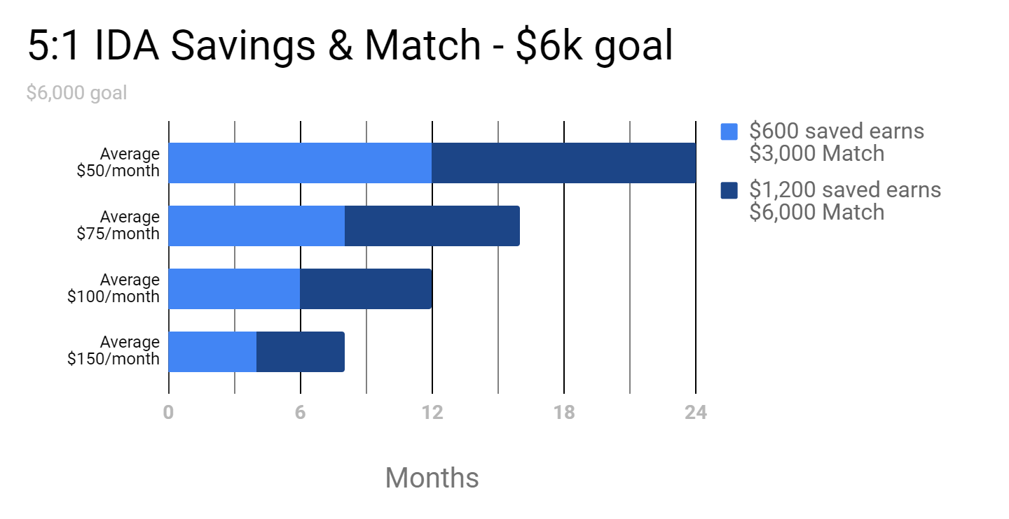

**How much do I have to save every month?**

The amount you decide to save will depend on your savings goal and your budget. For example, if you save $75 every month for 16 months, you’ll have $1,200 in savings and be eligible for $6,000 in match, for a combined $7,200 to put towards your goal! To encourage the practice of setting aside savings every month, participants are expected to deposit at least $25 each month.

**5:1 Match rate sample scenario for a $6,000 Goal:**

|  |  |  |  |
| --- | --- | --- | --- |
| Average monthly deposit | $300 saved earns $1,500 match | $600 saved earns $3,000 match | $1,200 saved earns $6,000 match |
| $50 | 6 months | 1 year | 2 years |
| $75 | 6months* | 8 months | 16 months |
| $100 | -* | 6 months | 1 year |
| $150 | -* | 6 months* | 8months |

*\* A saver has to be in the program for at least 6 months to be eligible for match.*

**What happens when I’m ready to make my purchase?**

When you have met your savings goal and finished all program requirements, you will use the match money plus your savings to make your purchase.

**Is there a limit to how much of my own funds I can save in my IDA savings account?**

No! You are always welcome to put as much as you are able into your IDA savings account. More savings provides more security for emergencies or other financial needs and goals. You will only receive match for the amount in your savings plan, but the account is and always will be yours. Any extra savings beyond that used toward your match goal at the end of your time in the program will be yours to decide how to use. If you leave before reaching your goal, for whatever reason, unspent match funds will be put back in the pool for other savers, but your personal savings portion will remain in your account, available for your withdrawal.

**How do I know this isn’t a scam?**

The Oregon IDA Initiative has been providing this opportunity to Oregonians for over 20 years. IDAs are funded by the State of Oregon and administered by reputable non-profits. The full amount of match money is saved for you in a separate account from the time you make your first deposit and the money that you save will always be yours, whether or not you complete the program.

**More about the Oregon IDA Initiative can be found at** [**https://oregonidainitiative.org/**](https://oregonidainitiative.org/)

**5:1 IDA Match Rate- with a $9,000 goal**

Insert your logo here…

**What if I have a $9k goal?**

The most you can earn in match is $6,000 in a 12-month period, so to receive $9,000 in match, a saver must have saved $1,800 in an IDA for more than 1 year (at least 12 months).

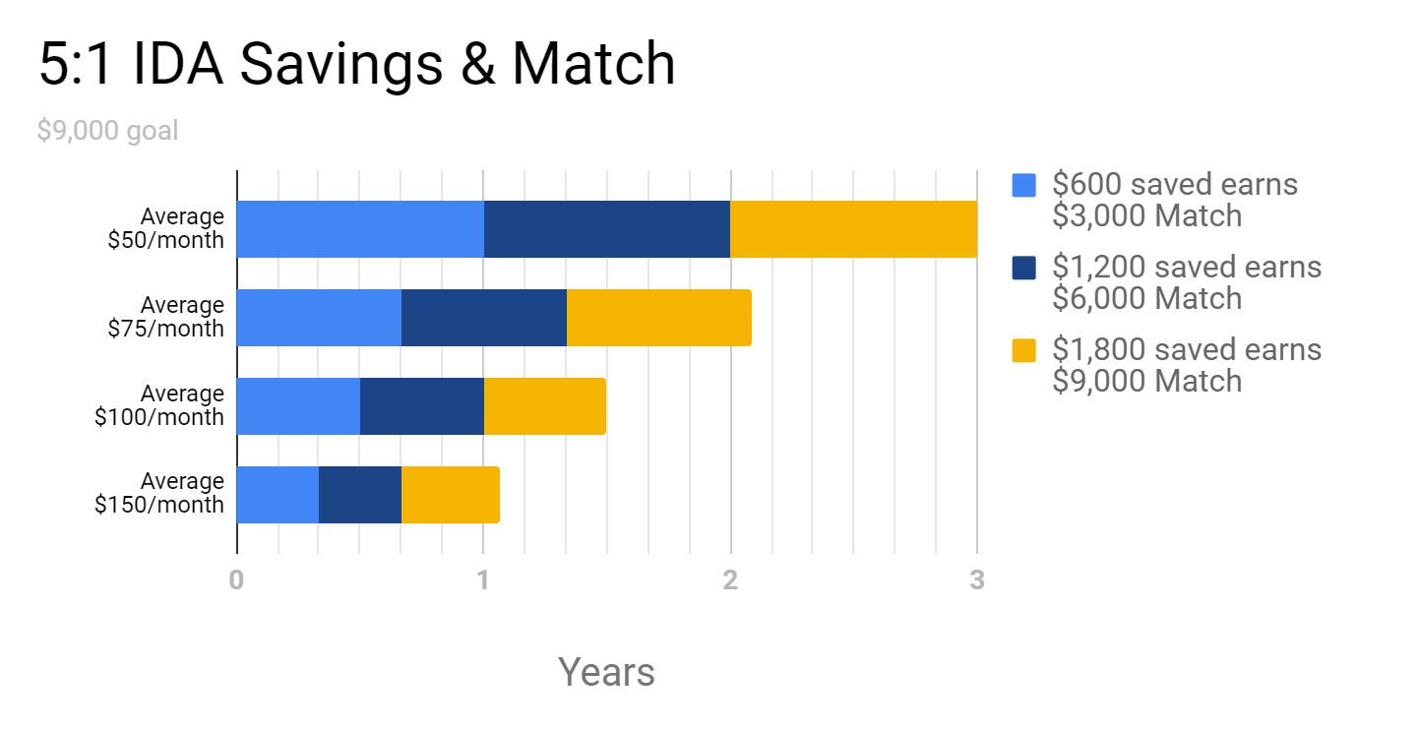

**5:1 Match rate sample scenario for a $9,000 Goal:**

|  |  |  |  |
| --- | --- | --- | --- |
| Average monthly deposit | $600 saved earns $3,000 match | $1,200 saved earns $6,000 match | $1,800 saved earns $9,000 match |
| $50 | 1 year | 2 years | 3 years |
| $75 | 8 months | 16 months | 2 years |
| $100 | 6 months | 1 year | 18 months |
| $150 | 6 months* | 8 months | 1 year** |

*\* A saver has to be in the program for at least 6 months to be eligible for match.*

**S*avers with $1,800 saved have to wait until after one full year in the program to get the full $9k in match. IDA savers can only get $6,000 in match money per 12 months.*