How to add New Questions
You do not have to create the new Questions and Values. VistaShare will do this part for the whole Initiative. However, your agency has to add the new Question to the Activity and associated forms. Note: Questions may exist in multiple forms. For example, a self-service form and a data entry form. If so, Questions would need to be added to both forms.
To do so:
- Log in to Outcome Tracker.
- Click Activities Tab.
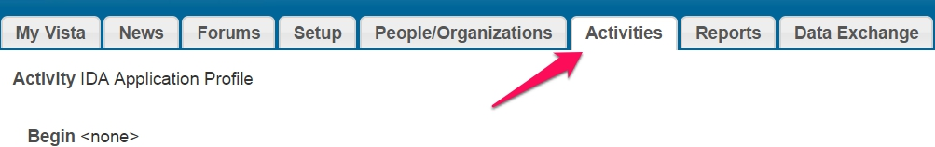
- Click the Activity to which the question will be added (for example, IDA Application Profile).
- Click the Questions Tab.
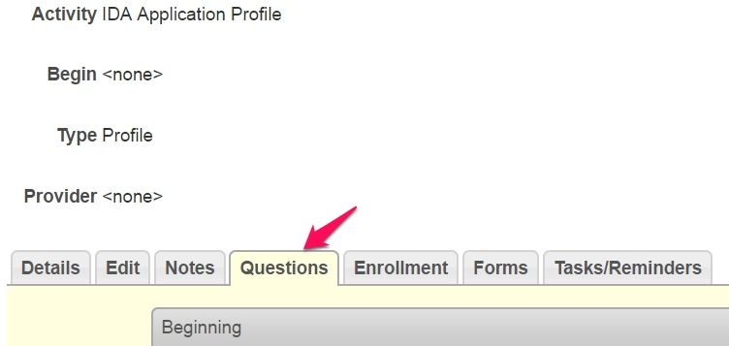
- Scroll down until you see the “Available Questions” box.

- Find the new Question(s) (the list is in alphabetical order) and highlight the Question(s) you want to add. Tip: You can hold down Ctrl to select multiple questions (hold down Shift more Mac). A comprehensive list of new questions is at the end of this document.
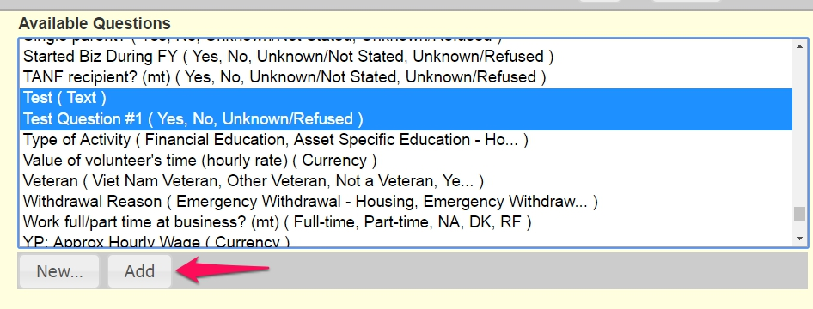
- Click Add when done.
- Click the Forms tab.
- Click the Form to which the Questions will be added (for example, Intake Form).
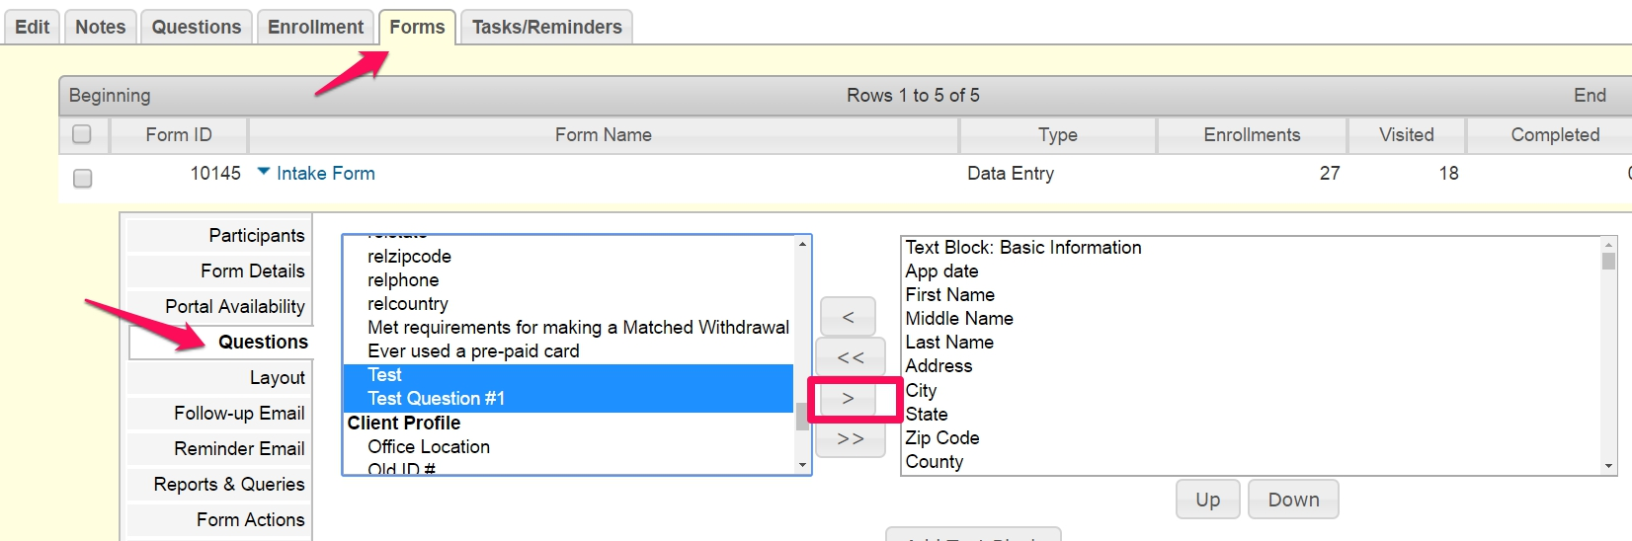
- Click the Questions tab within the Form. There will be two boxes. The left one will contain the new Questions.
- Find the new Question(s) and highlight. Tip: You can hold down Ctrl to select multiple questions (hold down Shift more Mac).
- Click the single right arrow to move the new Question(s) to the form.
- Click Save when done.

This will place your new Questions to the bottom of the form. To move them to the correct spot, follow the instructions below.
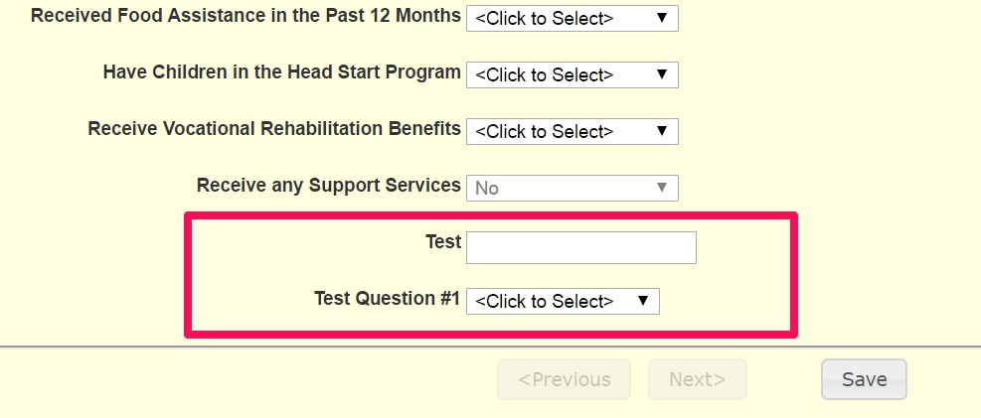

How to Reorder Questions
- In the Questions tab, find the new Question(s) in the right box. They should be at the bottom of the list.
- Highlight the Question(s) you want to reorder. Tip: You can hold down Ctrl to select multiple questions in order to move blocks of questions (hold down Shift more Mac).
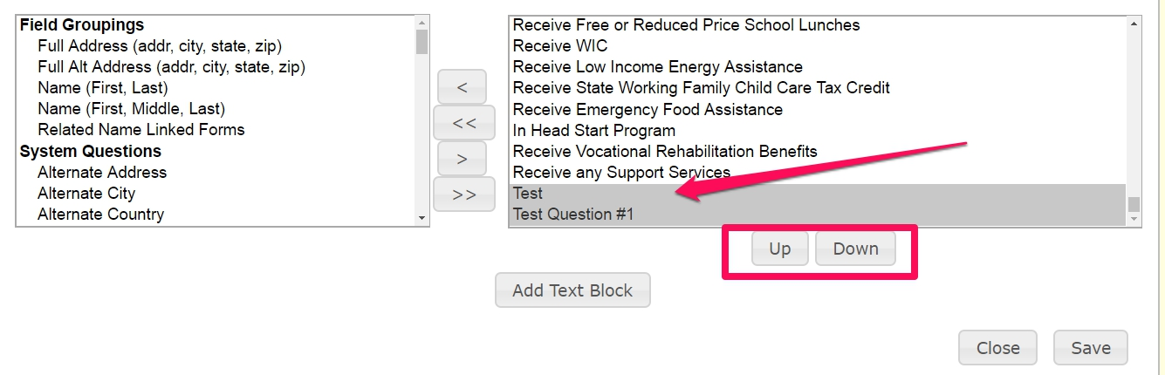
- Click the Up or Down buttons to move the Question(s).
- Click Save when done.

The New Questions to Add to your Forms

Intake—for All Participants
FO transferred from
System Name ID if transferred
If you identify your race or ethnicity in a way that is not listed, please tell us.
Household’s Housing Situation
Household’s Housing Situation –Other
Employment – Other
Hispanic? (from Client profile)
Prepaid Card Use
Intake—for Business Participants
Self-employed?
Self-employed? Other
Business gross sales, last calendar year
Business profits, last calendar year

Intake—for Education Participants
SSN (System question)
Decline to provide Social Security Number
Parents’ Highest Level of Education

Exit Information—all Participants
Financial Education Completed Date
IDA Program Options Used
Info not available/Participant Declines to Answer

Exit Information—Business savers
Name of Business
Web address of business
Business Industry
Business Industry-Other
Used IDA asset to leverage Business Loan or Line of Credit?
Self-employed? [at exit]
Self-employed? Other [at exit]
Business gross sales, last calendar year [at exit]
Business profits, last calendar year [at exit]

Exit information—Education savers
Name of educational institution

Exit information—Home purchase savers
Non completion reason
Non completion reason-Other
Purchase price of home

