How to Remove Questions: Contents

Remove Form Actions (From Intake and Exit) 1

Intake 1

Exit 5

How to Remove Questions from Forms 10

Questions that can be Removed from your Forms (that NP no longer needs collected) 12

**Intake—Data no longer needed** 12

**IDA at Exit Activity--Data no longer needed** 14

# Before you Begin

You will need to remove Form Actions that are associated with Questions before you can remove them. This document first explains how to remove form actions and the form actions we know of that need to be removed. It then explains how to remove Questions from Forms.

# Remove Form Actions (From Intake and Exit)

## Intake

1. Log in to VistaShare
2. Click the Activities Tab

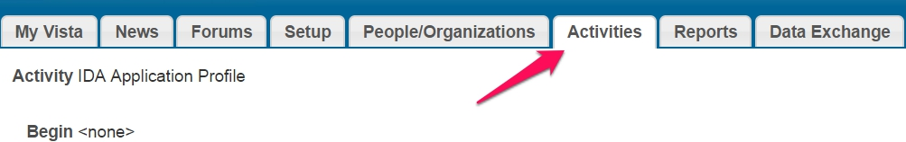

1. Click the IDA Application Profile.
2. Click the Forms tab.

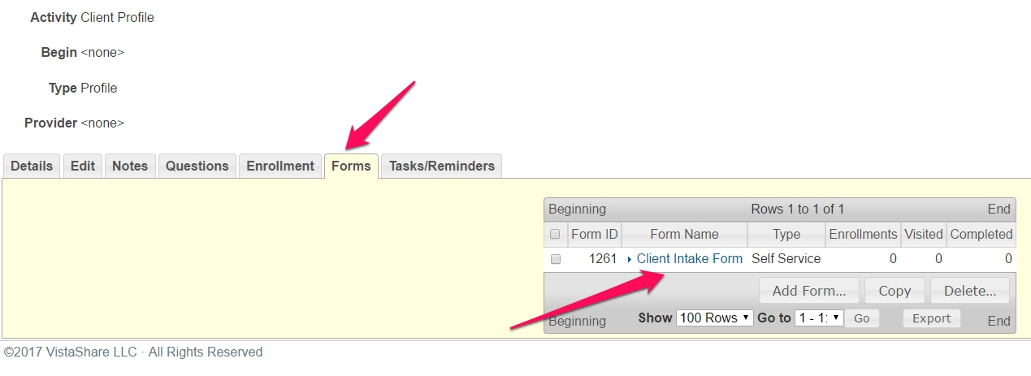

1. Click Intake Form
2. Click Form Actions tab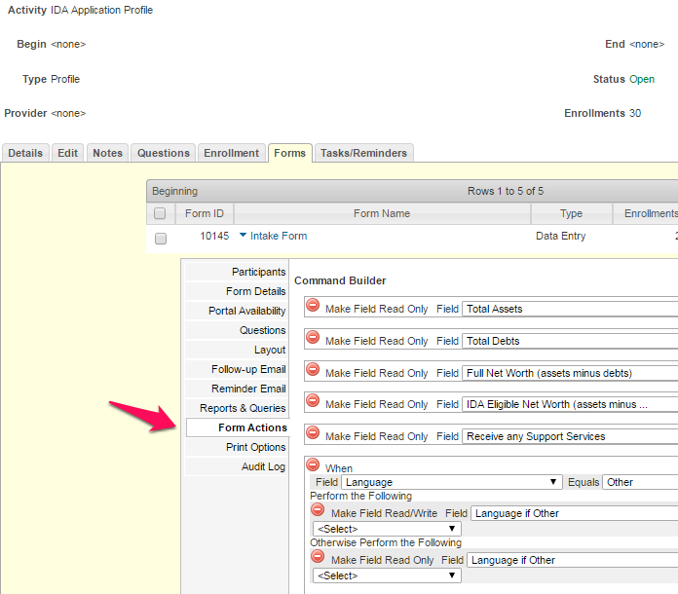
3. You will remove a set of form Actions.
   1. Click on the red-circle-with-minus-sign next for each section:
      1. Make Field Read Only Field “Receive any Support Services”

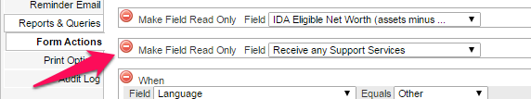

* + 1. When Field “Housing type”

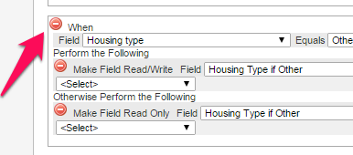

* + 1. Set Field “Total Household Income”

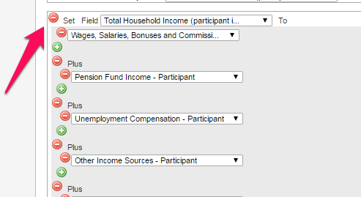

* + 1. When (Field Do you currently receive TANF?

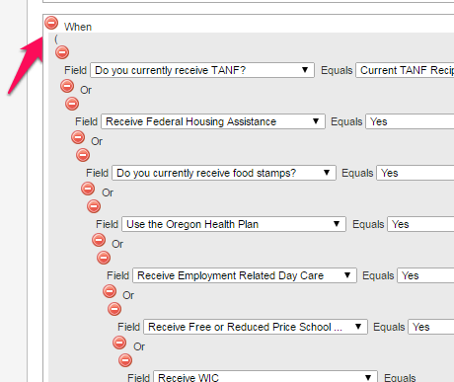

* + 1. When Number of Income Earners in the HH

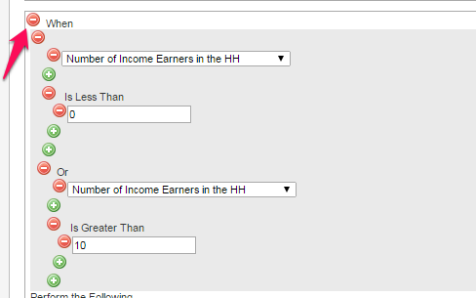

1. Scroll down until you see Save. Click Save.

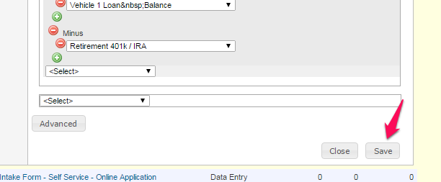

NOTE: If you have a self-service form, you may need to repeat this process with the self-service form.

## Exit

1. Log in to Outcome Tracker
2. Click the Activities Tab



1. Click the IDA at Exit Information
2. Click the Forms tab.



1. Click Exit Data form
2. Click Form Actions tab



1. You will remove a set of form Actions. (Reminder: We are in the IDA Exit Data form.)
   1. Click on the red-circle-with-minus-sign next for each section:
      1. Make Field Read Only Field “Receive any Support Services”



* + 1. When Field “Housing type”



* + 1. Set Field “Total Assets”

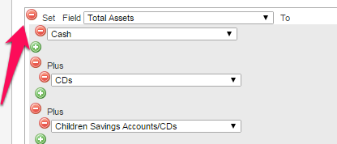

* + 1. Set Field “Total Debts”

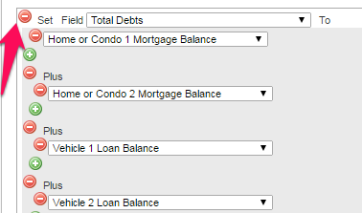

* + 1. Set Field “Full Net Worth…” and Set Field “IDA Eligible Net Worth…”

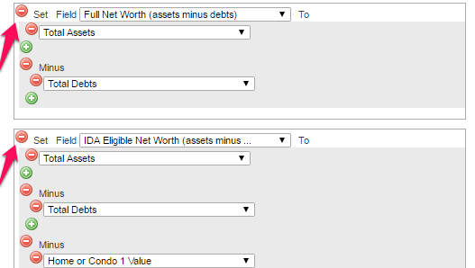

* + 1. Make Field Read Only Field “Total Household Income” and Set Field “Total Household Income”

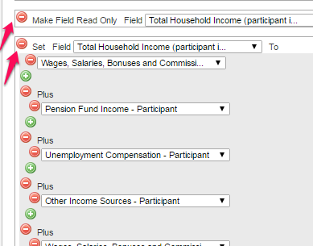

* + 1. When (Field Do you currently receive TANF?



* + 1. When Number of Income Earners in the HH



1. Scroll down until you see Save. Click Save.



NOTE: If you have a self-service form, you may need to repeat this process with the self-service form.

# How to Remove Questions from Forms

**Please do not delete Questions from Activities but instead remove them from the Form within the Activity.** Deleting a Question from an Activity will delete the data that was collected. Note: Questions may exist in multiple forms. For example, a self-service form and a data entry form. If so, Questions would need to be removed from both forms.

1. Log in to Outcome Tracker.
2. Click the Activities Tab.
3. Click the Activity to which the question will be removed from (for example, IDA Application Profile).
4. Click the Forms Tab.



1. Click the form from which the Questions will be removed from (for example, Client Intake Form).

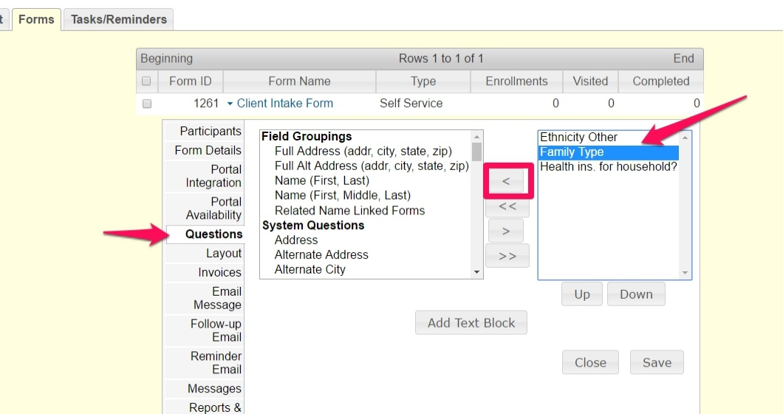

1. Click the Questions tab. There will be two boxes. The right one will contain the existing Questions.
2. Find the Question(s) and highlight. Tip: You can hold down Ctrl to select multiple questions (hold down Shift more Mac). A list of questions to remove is at the end of this document.
3. Click the single left arrow to remove the Question(s) from the form.
4. Click Save when done.

# Questions that can be Removed from your Forms (that NP no longer needs collected)

**Intake—Data no longer needed**

| *Question* | *Activity/Profile* | *Reason* |
| --- | --- | --- |
| Family type | Client | Not used by NP. We can use “marital status” and “Number of Children” to characterize households if needed. |
| Farmworker | Client | Not useful for the evaluation. |
| Housing Type | Client | Using “Household Housing Situation” instead. |
| Housing Type if Other | Client | Using “Household Housing Situation” instead. |
| Youth at Intake (under 18) | Application | The evaluation uses birthdate instead. |
| Live on a Reservation | Application | Not useful for the evaluation. |
| Location (Urban/Rural) | Application | NP uses city and county instead. |
| School Status | Application | Not useful for the evaluation. |
| Investment owner [Do you own your own stocks, bonds, or 401k or other investments?] | Application | No longer requested by AFI. We have other fields for amount held in stocks, bonds, 401k or other investments. |
| Credit Card Balance (Visa…) [Do you have any credit card bills?] | Application | No longer requested by AFI. We have another field for amount of credit card debt. |
| Do you owe money to family or friends | Application | No longer requested by AFI. We have another field for amount owed to friends or family. |
| Medical Bills [Do you have outstanding medical bills?] | Application | No longer requested by AFI. We have another field for amount of medical bills. |
| Student Loans [Do you have outstanding student loans?] | Application | No longer requested by AFI. We have another field for amount of student loans. |
| AFI Eligible? Yes/No | Application | Not used by NP. |
| ***Income*** |  |  |
| Wages, salaries, bonuses and commissions—Participant | Application | Details needed about income will be in the income calculator. |
| Pension fund income—Participant | Application | Details needed about income will be in the income calculator. |
| Unemployment compensation—Participant | Application | Details needed about income will be in the income calculator. |
| Other Income Sources—Participant | Application | Details needed about income will be in the income calculator. |
| Wages, salaries, bonuses and commissions—Others in Household | Application | Details needed about income will be in the income calculator. |
| Pension fund income—Others in Household | Application | Details needed about income will be in the income calculator. |
| Unemployment compensation—Others in Household | Application | Details needed about income will be in the income calculator. |
| Other Income Sources—Others in Household | Application | Details needed about income will be in the income calculator. |
| Number of Income Earners in the Household | Application | No longer requested by AFI. |
| ***Support Services*** |  |  |
| Receive Food Stamps | Application | Not useful for the evaluation. |
| On Oregon Health Plan | Application | Not useful for the evaluation. |
| Receive Employment Related Day Care | Application | Not useful for the evaluation. |
| Receive Free or Reduced Price School Lunches | Application | Not useful for the evaluation. |
| Receive WIC | Application | Not useful for the evaluation. |
| Receive LIEAP | Application | Not useful for the evaluation. |
| Receive State Working Family Child Care Tax Credit | Application | Not useful for the evaluation. |
| Receive Emergency Food Assistance | Application | Not useful for the evaluation. |
| In Head Start | Application | Not useful for the evaluation. |
| Receive Vocational Rehabilitation Benefits | Application | Not useful for the evaluation. |
| Receives Any Support Services | Application | Not useful for the evaluation. |

**IDA at Exit Activity--Data no longer needed**

| *Question* | *Reason* |
| --- | --- |
| Did the participant reach their savings goal | Not used by NP. |
| Date reached goal | Not used by NP. |
| School Status | Only needed at intake. |
| Housing Type | Using “Are you a homeowner” instead. |
| Housing Type if Other | Only need “Household Housing Situation” at intake. |
| Number of Income Earners in the Household | No longer requested by AFI. |
| AFI Household Adults | No longer requested by AFI. |
| AFI House Children | No longer requested by AFI. |
| First Generation to Go to College | We are collecting Parents’ Highest Level of Education at Intake instead. |
| Degree/Educational Opportunity Pursued | Not used by NP. Expect to use National Student Clearinghouse to see degree attained. |
| Degree/Educational Opportunity Pursued Other | Not used by NP. |
| Location of the School | Using “Name of Educational Institution” instead. |
| ***Assets*** | ***Only needed at intake. Financial detail about total assets at exit not useful for the evaluation.*** |
| Cash | “ |
| CDs | “ |
| Checking Account(s) Amount | “ |
| Children Savings Accounts/CDs | “ |
| Business Bank Account(s) Amount | “ |
| Home or Condo 1 Value  Home or Condo 2 Value | Will replace with “Home Purchase Price” for Homeownership completers. |
| Retirement 401k / IRA | Detail about total assets at exit not useful for the evaluation. |
| Savings Account(s) Amount (not IDA) | “ |
| Stocks and Bonds (not retirement) | “ |
| Other Investments | “ |
| Vehicle 1 Value  Vehicle 2 Value  Vehicle 3 Value | “ |
| Business Assets/Inventory | “ |
| Other Assets | “ |
| Total Assets | “ |
| ***Liabilities*** | ***Only needed at intake. Financial detail about liabilities at exit not useful for the evaluation.*** |
| Home 1 Loan (or Home or Condo 1 Mortgage Balance)  Home 2 Loan | Will replace with “Home loan value” for homeownership completers. |
| Vehicle 1 Loan (or Vehicle 1 Loan Balance)  Vehicle 2 Loan  Vehicle 3 Loan | Liabilities at exit not useful for the evaluation. |
| Unpaid Income/Property Taxes | Liabilities at exit not useful for the evaluation. |
| Child Support Payments | “ |
| Credit Card Balance Amount (Visa…) | “ |
| Store Credit Debt | “ |
| Personal Line of Credit | “ |
| Medical Bills Balance | “ |
| Personal Debt Amount (to family…) | “ |
| Student Loans Balance | “ |
| Business Debts | “ |
| Other Debts | “ |
| Total Debts | “ |
| Full Net Worth (assets minus debts) | Net Worth at Exit not useful for the evaluation. |
| ***Income*** | ***Only needed at intake. Income at Exit not useful for the evaluation.*** |
| Wages, Salaries, Bonuses and Pensions-Participant | “ |
| Business Income/Self-Employment Income-Participant | Using other fields to learn about number of hours self-employed and business profits. |
| Pension/Retirement-Participant | Income at Exit not useful for the evaluation. |
| Unemployment Insurance-Participant | “ |
| Other Income Sources-Participant | “ |
| Other Income-Source-Participant | “ |
| Child Support/Alimony-Participant | “ |
| Employment salary/wages-Participant | “ |
| General assistance-Participant | “ |
| Other Income-Participant | “ |
| Social Security (SSI or SSD)-Participant | “ |
| Auxiliary/Dependent Benefits-Participant | “ |
| Wages, Salaries, Bonuses and Pensions-Other in HH | “ |
| Business Income/Self-Employment Income-Other in HH | “ |
| Pension/Retirement-Other in HH | “ |
| Unemployment Insurance-Other in HH | “ |
| Other Income Sources-Other in HH | “ |
| Other Income-Source-Other in HH | “ |
| Child Support/Alimony-Other in HH | “ |
| Employment salary/wages-Other in HH | “ |
| General assistance-Other in HH | “ |
| Other Income-Other in HH | “ |
| Social Security (SSI or SSD)-Other in HH | “ |
| Auxiliary/Dependent Benefits-Other in HH | “ |
| Total Household Income | “ |
| ***Benefits*** | ***Benefit receipt at exit not useful for the evaluation.*** |
| Receive Employment Related Day Care | Benefit receipt at exit not useful for the evaluation. |
| In Head Start Program | “ |
| On Oregon Health Plan | “ |
| Receive Emergency Food Assistance | “ |
| Receive Federal Housing Assistance | “ |
| Receive Low Income Energy Assistance | “ |
| Receive Free or Reduced Price School Lunch | “ |
| Receive WIC | “ |
| Receive State Working Family Child Credit | “ |
| Receive Food Stamps | “ |
| Receive Vocational Rehabilitation | “ |
| Receive Any Support Services | “ |