# How to Disable Values

1. Log in to Outcome Tracker.
2. Click Setup Tab.
3. Click Define Dropdown Lists under Activities.

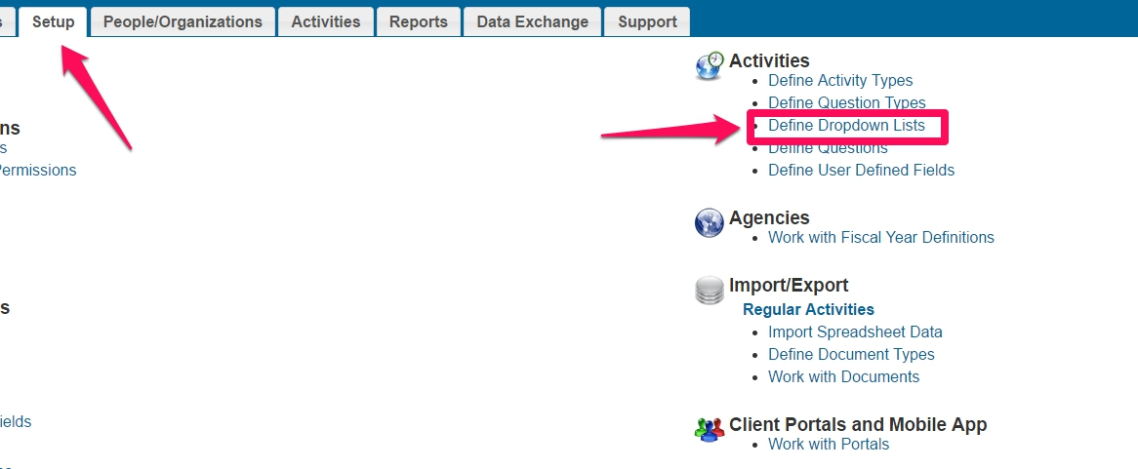

1. You will be presented with the list of Questions and Dropdown Values associated with the Question. Scroll down to find the Question from which you will disable Values or use the Search box.

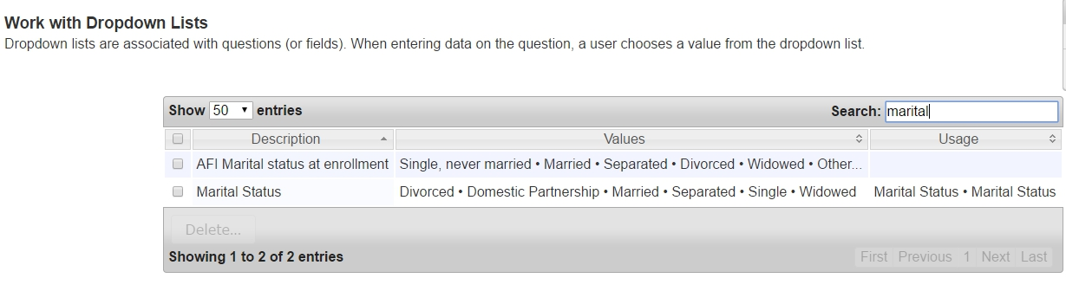

1. Click on the Question.
2. You will be presented with the Question’s dropdown values. Under the “Enabled” column, unclick the checkbox next to the Value you want to disable.

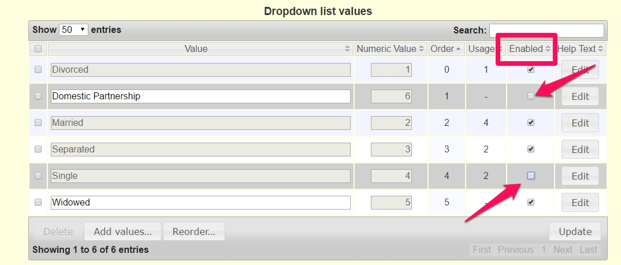

1. Click Update when done.

# List of Values that can be Disabled (NP no longer needs)

| **Question** | **Activity the question is found on** | **KEEP**  **(Enabled box should be checked)** | **Disable**  **(enabled box can be unchecked)** |
| --- | --- | --- | --- |
| Marital Status | System | Single, never married  Married  Separated  Divorced  Widowed  Declined to ID | Single  Domestic Partnership |
| Ethnicity | System | Black/African American  Asian, Pacific Islander  White  American Indian or Alaska Native  Multiracial  Unknown  Declined to ID | Alaska Native  Asian  African American  Caucasian  Native Hawaiian or Other Pacific Islander  Native American  Other/Multiple |
| Veteran | Client Profile | Yes  No  Unknown/Decline to Answer | Unknown/Refused |
| Foster Youth | IDA Application Profile | Yes  No Unknown/Decline to Answer | Unknown/Refused |
| Disability | IDA Application Profile | Yes  No  Unknown/Decline to Answer | Unknown/Refused |
| Education Completed | IDA Application Profile  And  IDA at Exit Info | Completed grades K-5  Completed grades 6-8  Completed grades 9-11  High school diploma/GED  Some college  Vocational School Diploma/Degree  AA degree/Graduated two-year college  BA/BS Degree/Graduated four-year college  Some graduate school/attended graduate school  Graduate degree  Declined to ID | Some high school  Two year degree  College graduate (four year)  MA/MS, etc. Graduate degrees |
| Employment | IDA Application Profile | Full Time Employed (35 or more hours per week, all jobs)  Part time/seasonally employed  Unemployed  Other (specify in open ended text box)  Declined to ID | Employed more than full time (41+ hours per week)  Part time employed  Unemployed-looking for work  Unemployed-disability  Unemployed –volunteer work  Unemployed-not looking for work Unemployed-not specified |
| Federal housing assistance | IDA Application Profile | Yes  No  Unknown/Declined to answer | Unknown/Refused |
| Closed Reason | IDA Account | Completed/Successfully made matched withdrawal  Financial need or emergency  Moved out of state/area  No longer interested in the program  Transfer to another FO  Transfer to a beneficiary  Violated program rules/could not meet program requirements | Graduated-Successfully completed program  Transfer account  Unable to make deposits  Voluntarily withdrew  Violated program rules  Could not meet program requirements |
| Account Intended Use | IDA Account | Varies by FO, but should draw from the following:  Assistive Technology  Business  Education  Employment-related equipment  Home Purchase  Home Renovation  Rental  Retirement  Transfer to Beneficiary (AFI only)  Vehicle | Transfer account—Education IDA  Youth |