How to Add Financial Capability Scale Activity

- Log in to Outcome Tracker
- Click Setup tab
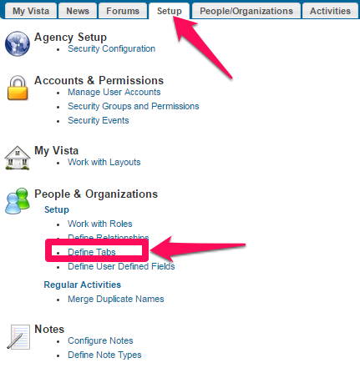
- Under People & Organizations, click “Define Tabs”
- Click “Add Tab…” A pop-up window will appear called “Add Tab.”
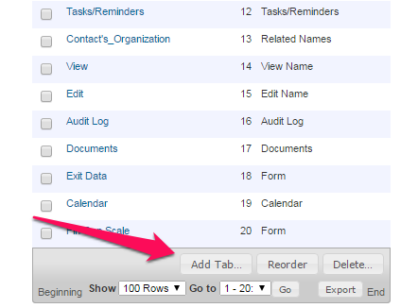
  - In Tab Description, type in “Fin Cap Scale”
  - In the Component dropdown choose “Form”
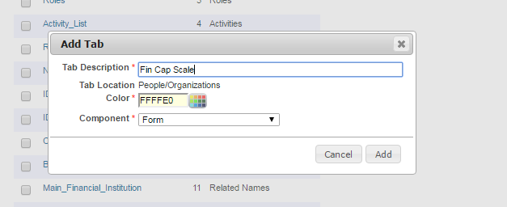
  - Click Add. This will take you to a new screen
- Click “Configure Data Entry Form Tab.” A pop-up window will appear called “Configure Data Entry Form Tab.”
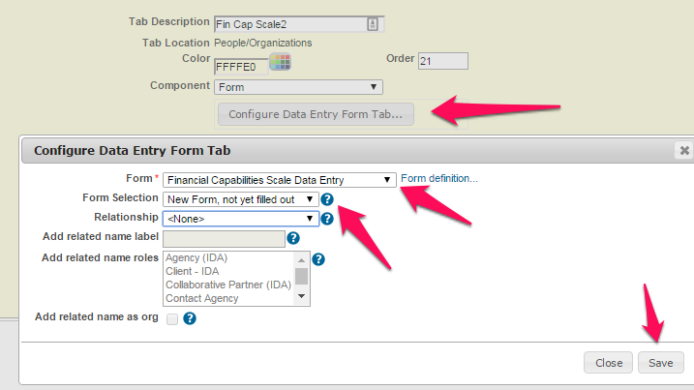
  - In the Form dropdown, choose “Financial Capabilities Scale Data Entry”
  - In the Form Selection dropdown, choose “New Form, not yet filled out”
  - Leave Relationship dropdown as “ <None>”
  - Click Save. You will get a warning that states that the “tab is not configured to display anywhere.” Ignore the warning.
- In the “Show on Roles” box, choose “Client – IDA” (or whatever role you call your IDA Clients). This will add the Financial Capabilities Scale Activity and Form to all people with “Client – IDA” roles.
- Click Update.

